# Workflow Documentation

## Background:

Workflow is a minimalist workflow designer

## Screen Layout:

Validation Indicator

Command menu

Drawing Surface

Definition Panel

Property Panel

Element Palette

## Components:

### Command Menu:

The command menu contains buttons that affect the overall workflow drawing.

* Clear: Completely clears the drawing surface
* Template: Completely clears the drawing surface and then adds a Start and End element to the drawing surface.
* Zoom to Fit: zooms the drawing either in or out so that it covers the complete drawing surface.
* Reconnect Links: Recalculates the links between elements so that the patch are the shortest distance between two elements

### Validation Indicator:

The system constantly re-evaluates the drawing according to certain rules. The indicator shows if the drawing is valid or not. Hovering your mouse over the indicator will show a tooltip containing the reasons why the drawing is invalid.

The rules followed are:

* There must be one and only one Start element
* There must be one and only one End element
* Every element must have at least one valid link
* Every link must have a start and end element

### Element Palette:

The element palette lists all the available elements. Elements can be added to the drawing surface by either dragging them from the palette, or by double-clicking on a picture in the palette.

### Property Panel:

The property panel displays the properties of the currently selected element. The name, description and label properties may be changed by the user. To apply a property change, click on the Apply button.

### Definition Panel:

The definition panel constantly updates as the drawing changes, displaying all the drawing components and their properties in JSON format.

### Drawing Surface:

The drawing surface is where the user draws the workflow diagram. Elements are added to the drawing surface by either dragging them form the element palette, or by double-clicking on one of the symbols in the drawing palette.

Every element on the drawing surface will display a certain number of anchor points (or ports). Links can be draw between elements by dragging one anchor point to an anchor point on another element. An anchor point will turn black when it can be dragged or when an link can be dropped onto it.

**Vertices** can be created by clicking on a link. Once created, the vertex can be dragged to change the shape of the link. Vertices are deleted by double-clicking on it again.

Any element and link can be **deleted** by selecting it and hitting the Delete button on the keyboard. To select a link, click on the arrow at the end of the link.

Multiple objects can be **selected** by holding in the shift-key and dragging the mouse pointer over the objects to be selected.

The user may **zoom** in and out with the mouse scroll wheel.

The diagram can be **moved** by clicking-and-holding the mouse button on any empty space. Dragging the mouse will then move the image.

Element

Link

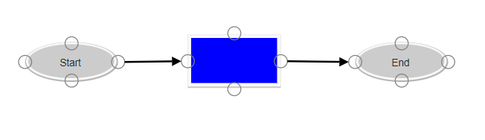

Anchor Point